Laura Gordon
SOC enviroment
Alerts

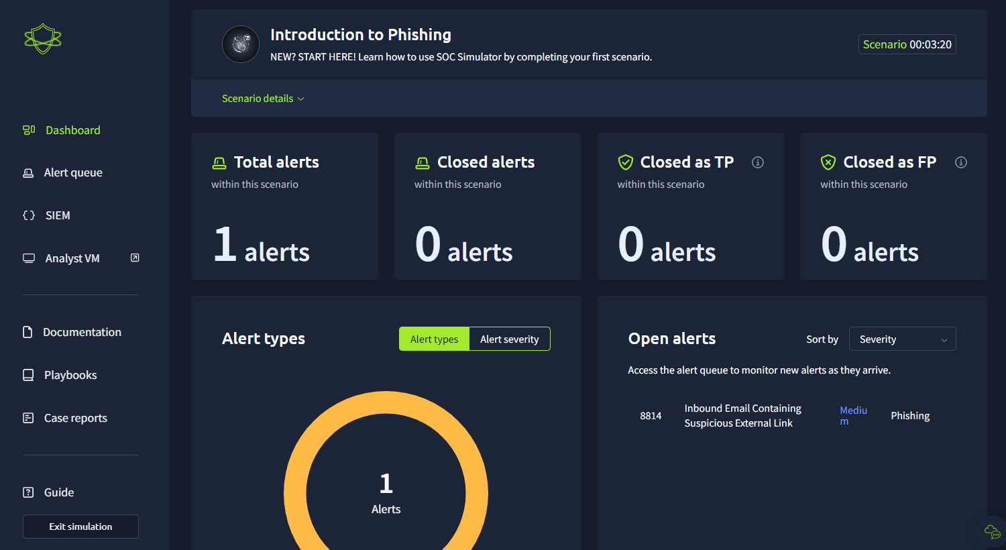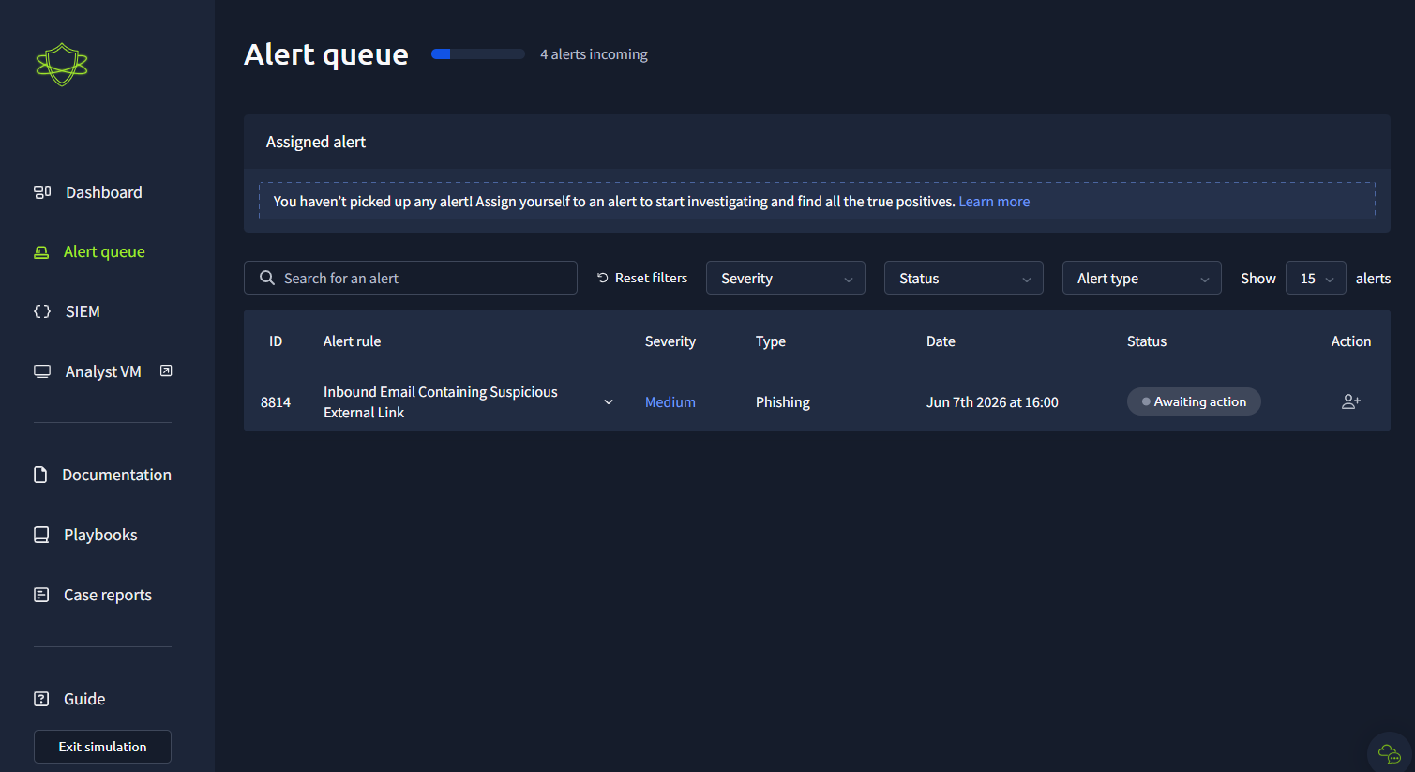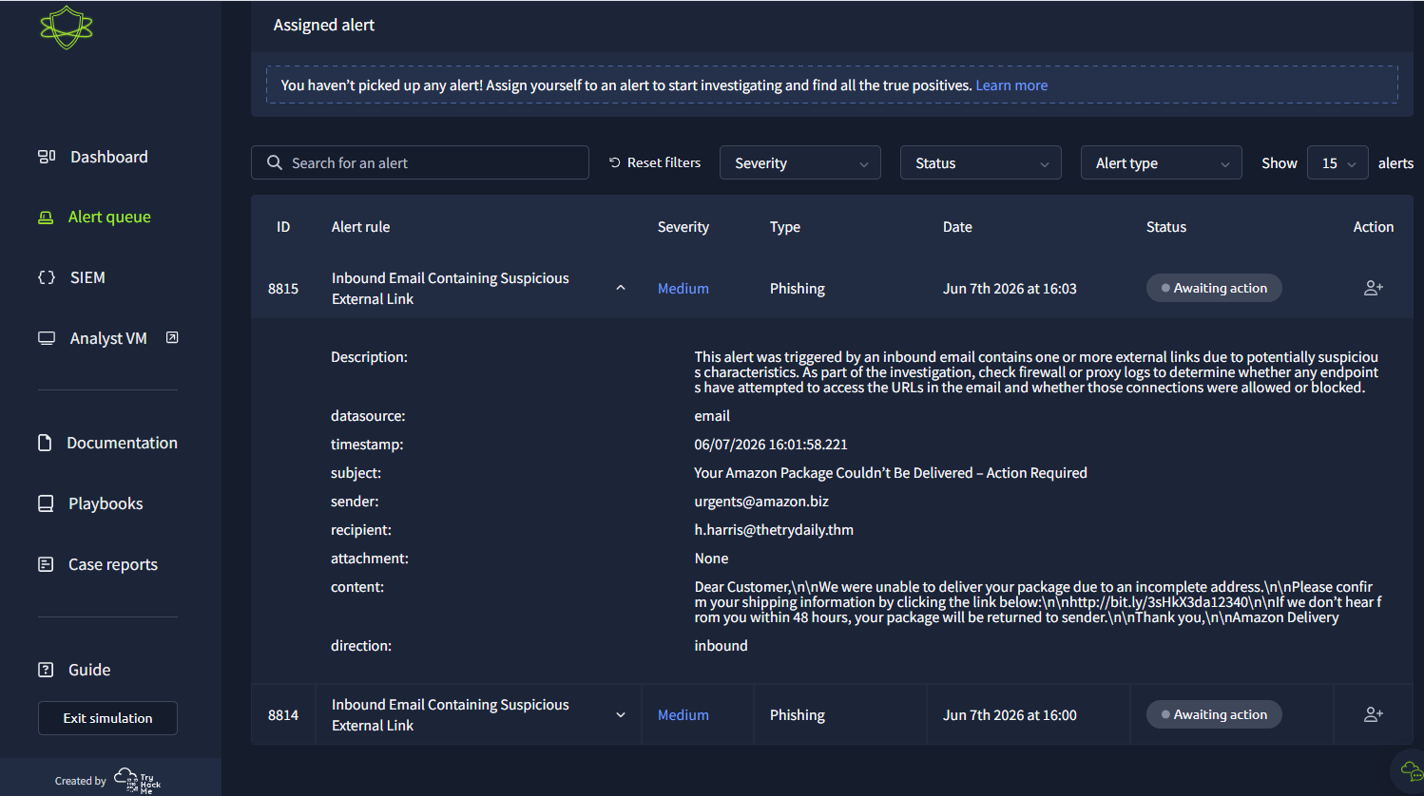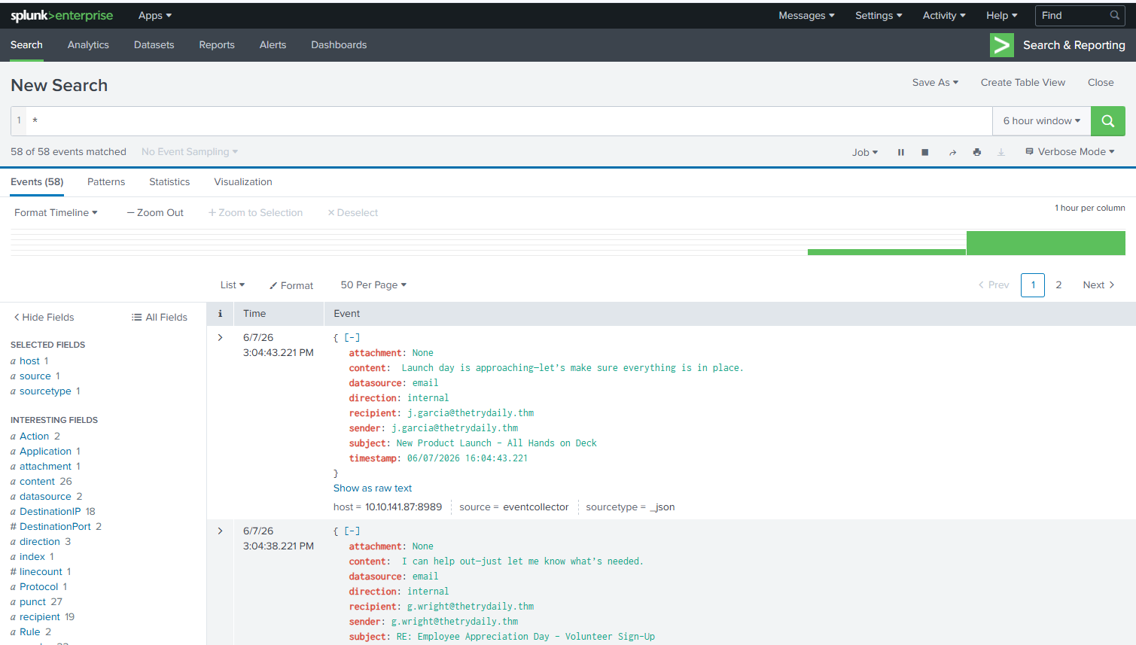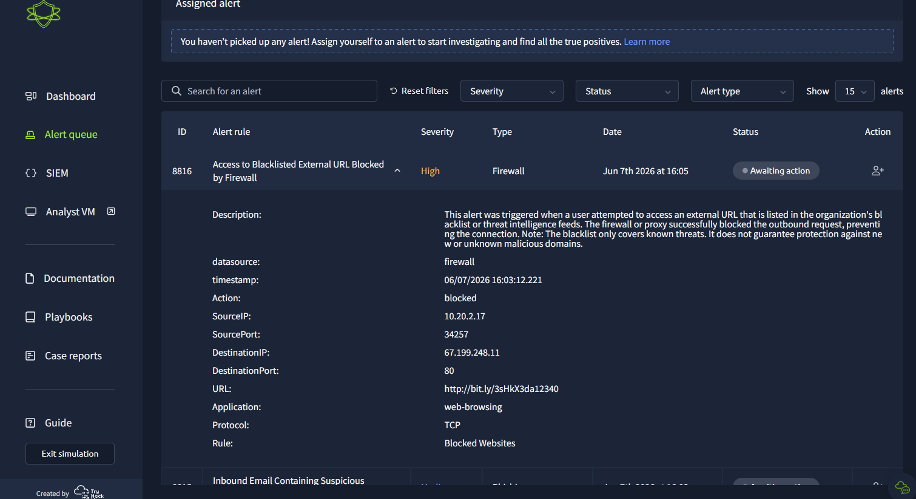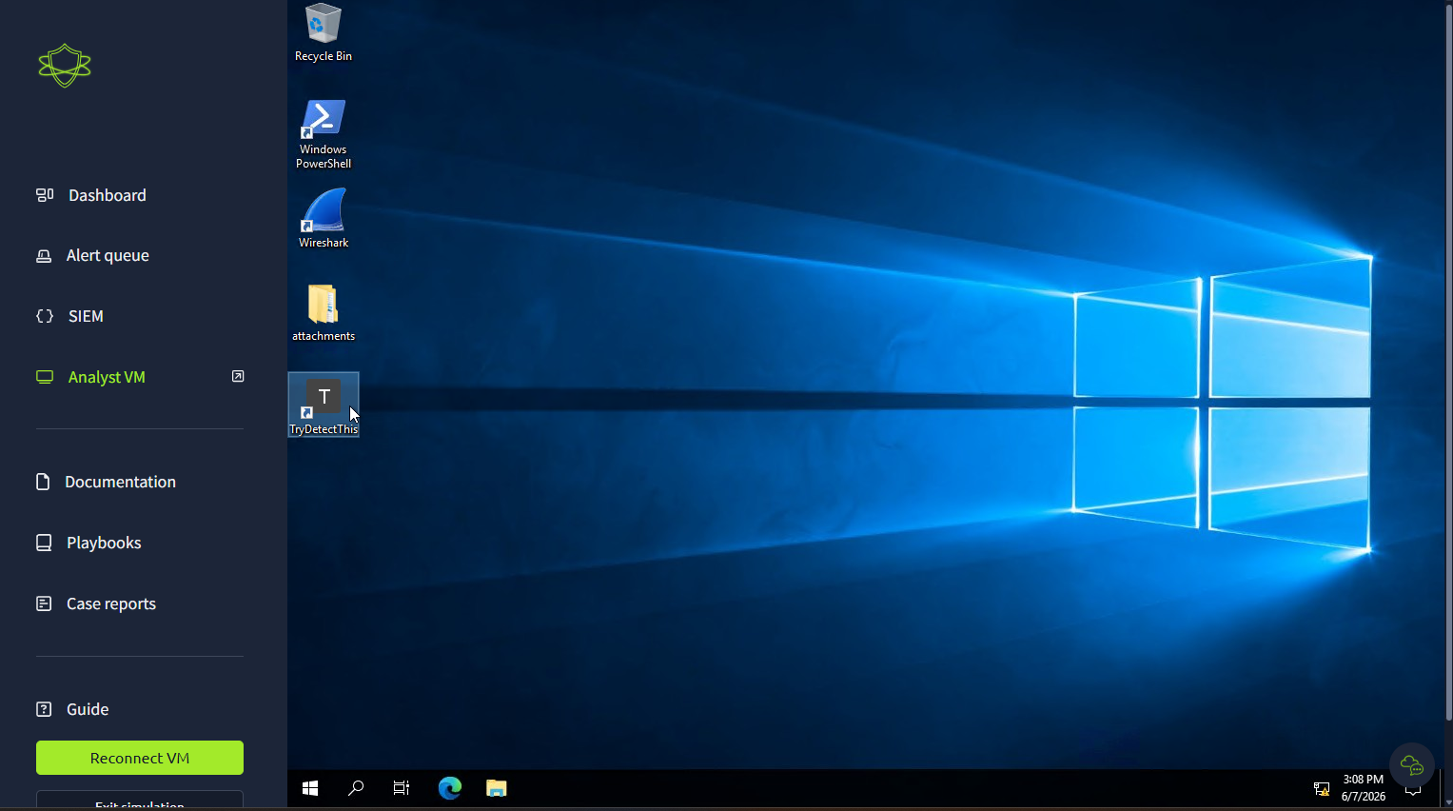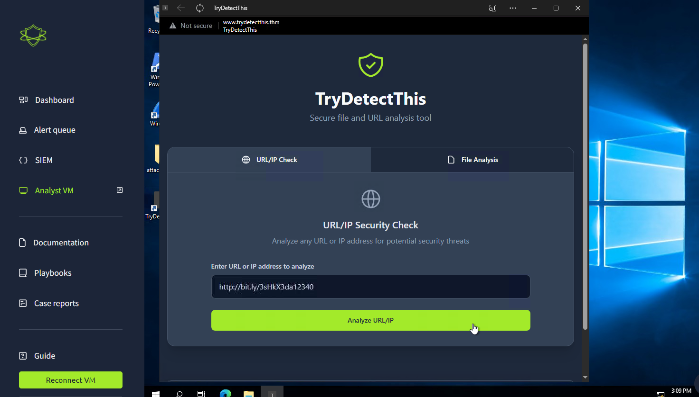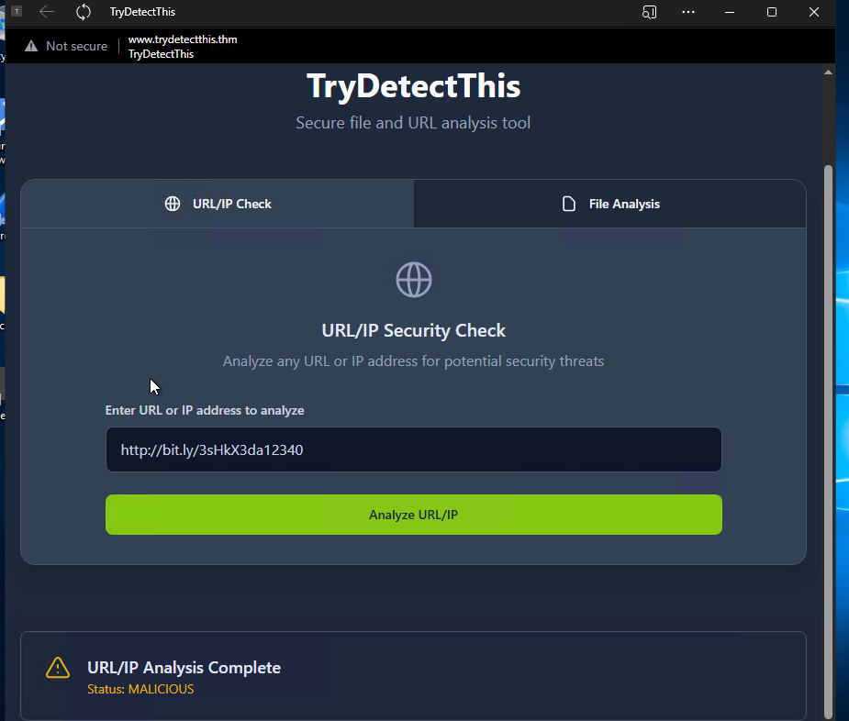

Security Incident Report – Access to Blacklisted External URL Blocked by Firewall
Alert Name
Access to Blacklisted External URL Blocked by Firewall
Alert Classification
True Positive (TP)

Executive Summary
This alert was classified as a True Positive after investigation confirmed that a user attempted to access a malicious URL that was already identified on the organization’s blacklist and threat intelligence feeds. The firewall successfully blocked the outbound connection, preventing communication with the malicious destination.
Further analysis using the TryDetectThis URL/IP analysis tool identified the URL as malicious, confirming that the activity represented a genuine security threat rather than normal user behavior or a false detection.
Immediate escalation is recommended because the activity may indicate phishing interaction, malicious link execution, or attempted malware delivery from an internal host.
Time of activity: 06/07/2026, 16:03:12

List of Affected Entities:
- Source Host/IP: 10.20.2.17
- Destination IP: 67.199.248.11
- URL Accessed: http://bit.ly/3sHkX3da12340
- Application: Web-Browsing
- Protocol: TCP
- Destination Port: 80
- Environment: TryHatMe

Reason for Classifying as True Positive: This activity is classified as a True Positive because an internal host attempted to access a URL identified as malicious by organizational threat intelligence and blacklist feeds. The firewall successfully blocked the outbound connection. Further investigation using the TryDetectThis analysis platform confirmed the URL status as MALICIOUS. The activity is consistent with malicious web traffic and potential phishing or malware-related behavior.

Reason for Escalating the Alert:This alert requires escalation because a corporate endpoint attempted communication with a verified malicious external resource. Although the firewall blocked the request, the event may indicate phishing interaction, malicious link execution, browser compromise, or attempted malware delivery. Additional endpoint investigation is required to determine whether the host was exposed to malicious content before the connection was blocked.

Recommended Remediation Actions:
- Isolate and investigate host 10.20.2.17
- Perform endpoint malware and antivirus scans
- Review browser history and downloaded files
- Block associated malicious IPs and URLs across security tools
- Reset potentially compromised credentials
- Review email activity for phishing indicators
- Monitor for repeated outbound connection attempts
- Update firewall and threat intelligence signatures

List of Attack Indicators:
- Source IP: 10.20.2.17
- Source Port: 34257
- Destination IP: 67.199.248.11
- Destination Port: 80
- URL: http://bit.ly/3sHkX3da12340
- Protocol: TCP
- Rule Triggered: Blocked Websites
- URL Reputation: MALICIOUS

False Positive Phishing email
Time of Activity: 06/07/2026 16:04:44 UTC

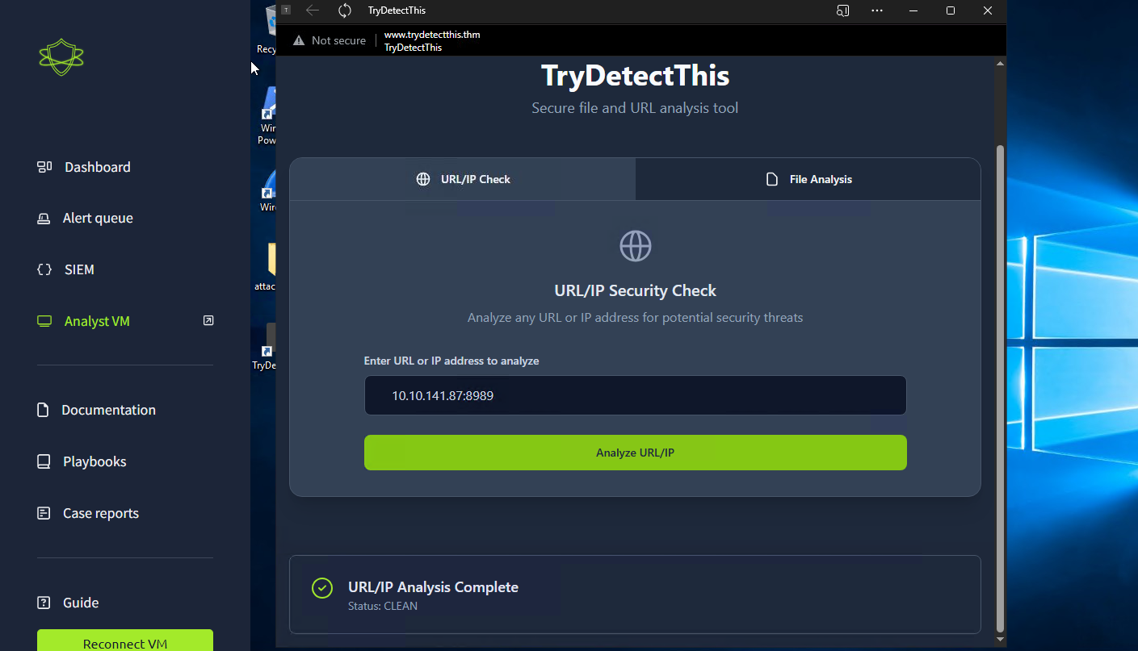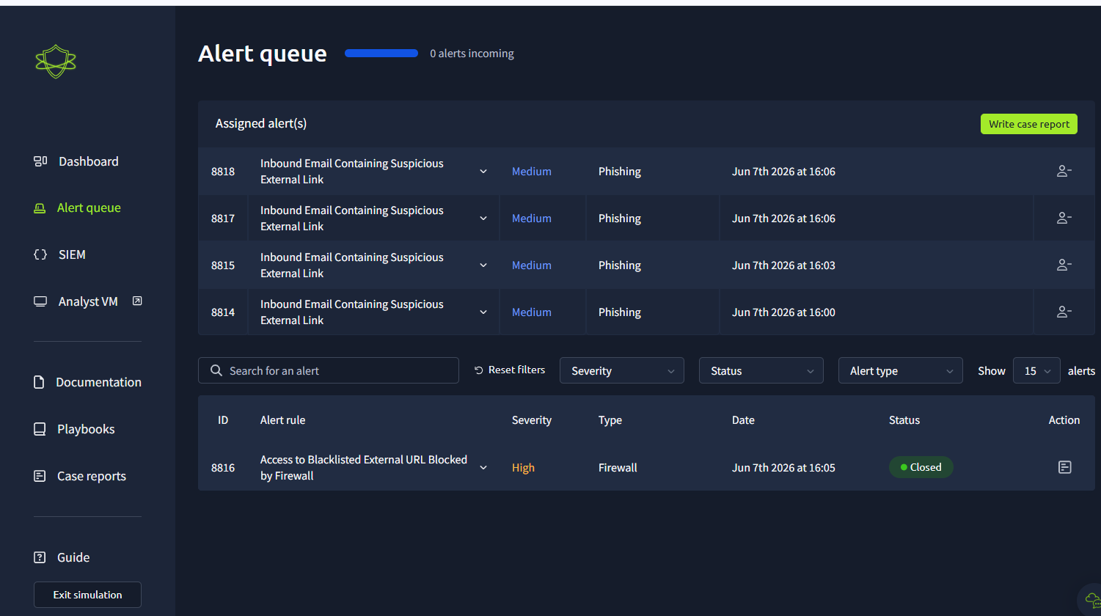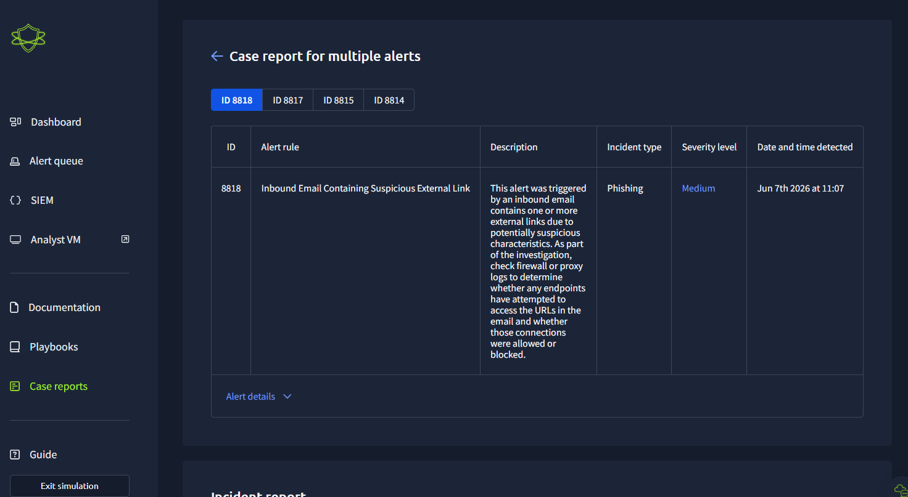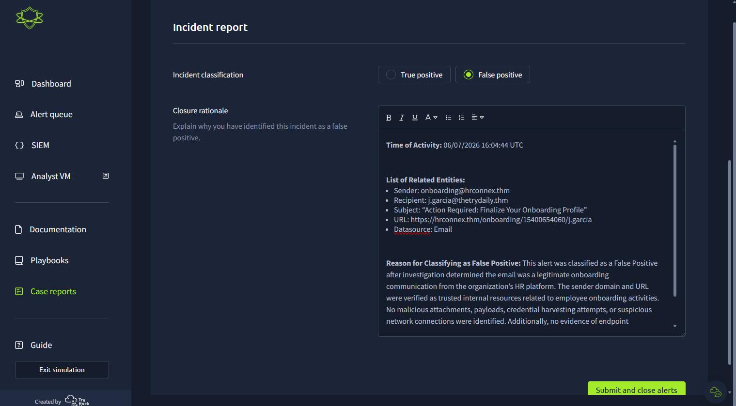

List of Related Entities:
- Sender: onboarding@hrconnex.thm
- Recipient: j.garcia@thetrydaily.thm
- Subject: “Action Required: Finalize Your Onboarding Profile”
- URL: https://hrconnex.thm/onboarding/15400654060/j.garcia
- Datasource: Email

Reason for Classifying as False Positive: This alert was classified as a False Positive after investigation determined the email was a legitimate onboarding communication from the organization’s HR platform. The sender domain and URL were verified as trusted internal resources related to employee onboarding activities. No malicious attachments, payloads, credential harvesting attempts, or suspicious network connections were identified. Additionally, no evidence of endpoint compromise or unauthorized activity was observed in firewall, proxy, or endpoint logs. The alert was triggered due to the presence of an external link within the email, which matched the phishing detection rule logic.

